Current Activities & Acquisitions
We continue to receive donations from various sources. Since the last newsletter we have received:

Redwing hard disk IBM 0681

Redwing was IBM Hursley Laboratory's last hard disk product. It was announced by IBM in 1990 and had a capacity of 471 MB (megabytes) formatted (8 disks) or 857 MB formatted (12 disks); both with an areal density of 45.20 Mbits/sq in (1677 tpi * 26951 bpi).

Redwing was based on 5 ¼ inch platters - the last IBM Disk to use that size. The read/write heads were moved by a linear actuator and this was possibly the last disk to use this mechanism. Redwing was the first hard disk PRML Technology (Digital Read Channel with 'Partial Response Maximum Likelihood' algorithm)

This example was made at the IBM manufacturing plant at Havant, Hampshire.

Some prototype PS/2 adapter cards
Including XGA, RS/6000 display adapters, Token Ring and 3250 replacement. Below left is the XGA prototype with external chip socket, and right is one of the RS/6000 cards. All can be found on the web site at http://hursley.slx-online.biz/hardware-data-list.asp?hur_archive=1&offset=50.

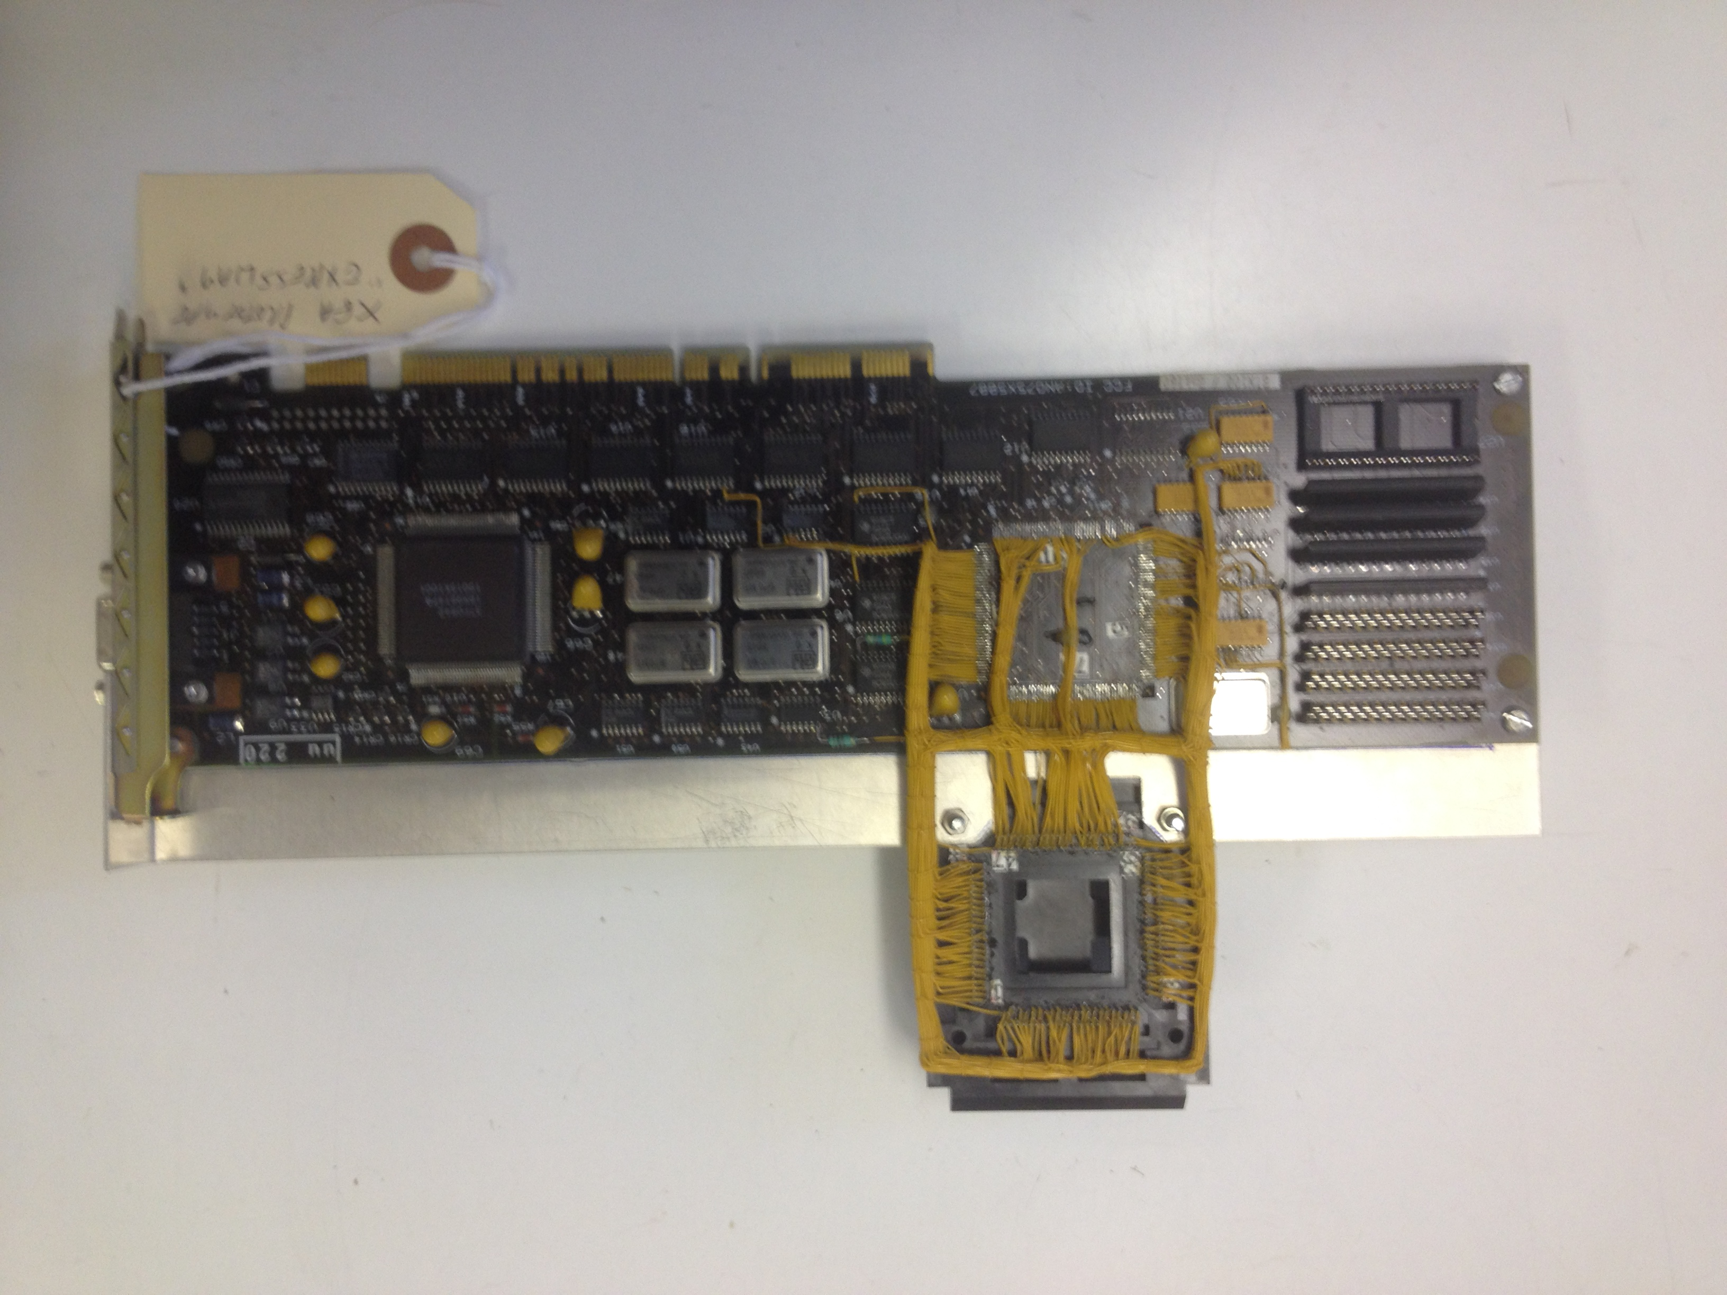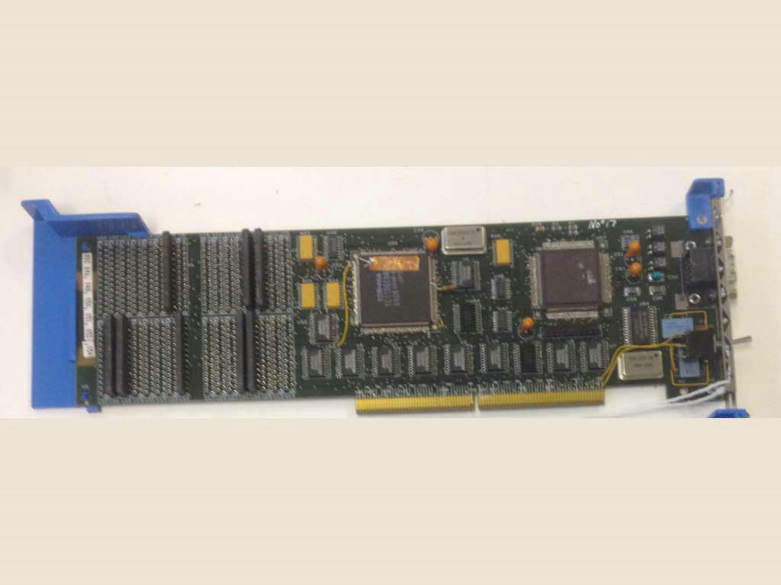

We now have two RS/6000 P5s running. The web site has been updated to reflect all of the changes to our display areas in the last 4 months. We have started to catalogue the vast collection of photographs, and done quite a bit of consolidation in the back office.

York Museum
Graham, one of Jim Austin's 'shedders' is due to collect our donations next month. These include both non-IBM and IBM artefacts.

